**EXPERIMENT - 12**

**AIM OF THE EXPERIMENT:**

To observe the output waveform of a Schmitt trigger circuit and to note

down the hysteresis voltage VHY with reference to upper and lower

threshold voltages VUT and VLT respectively.

**APPARATUS REQUIRED:**

PC loaded with multisim software

**THEORY:**

A **Schmitt Trigger** is a comparator circuit with hysteresis implemented by applying positive feedback to the noninverting input of a comparator or differential [amplifier](https://www.electrical4u.com/op-amp-working-principle-of-op-amp/). A Schmitt Trigger uses two input different threshold [voltage](https://www.electrical4u.com/voltage-or-electric-potential-difference/) level to avoid noise in the input signal.

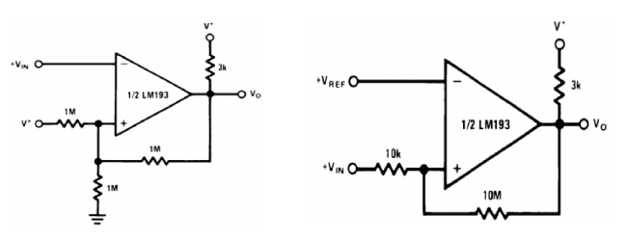The action from this dual-threshold is known as hysteresis.

The Schmitt trigger circuit can be designed using Op-Amp in two ways. If the input signal is connected at the inverting point of Op-Amp, it is known as Inverting Schmitt Trigger. And if the input signal is connected at the non-inverting point of Op-Amp, it is known as Non-inverting Schmitt Trigger.

**IMPLEMENTATION:**

Circuit Diagram

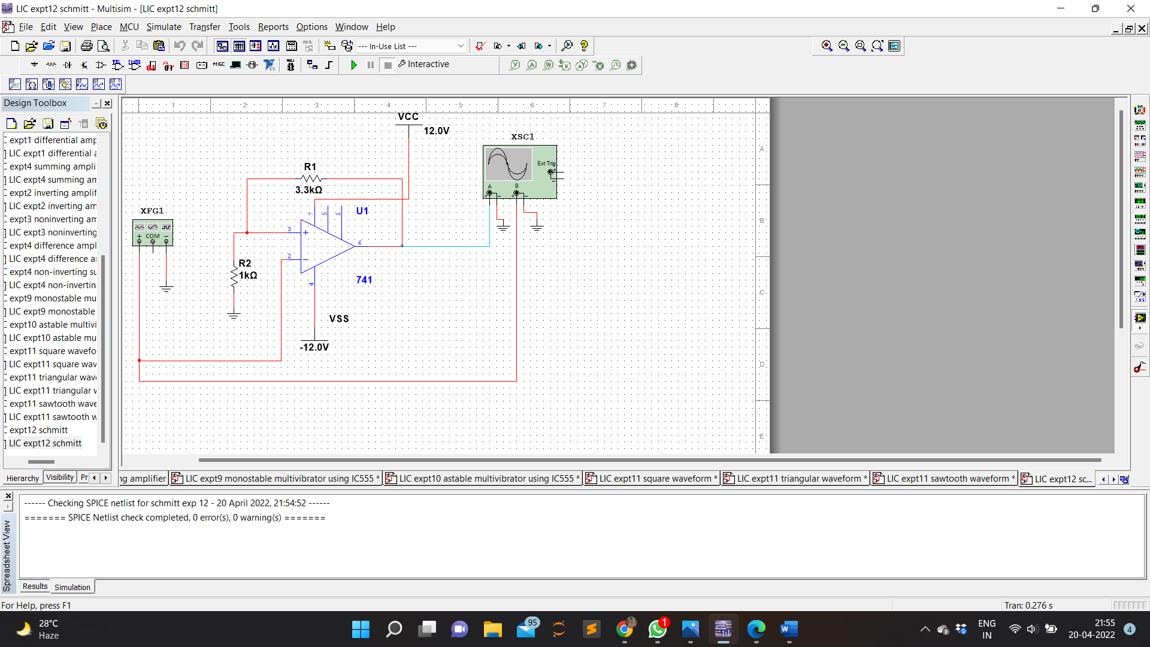

Waveform

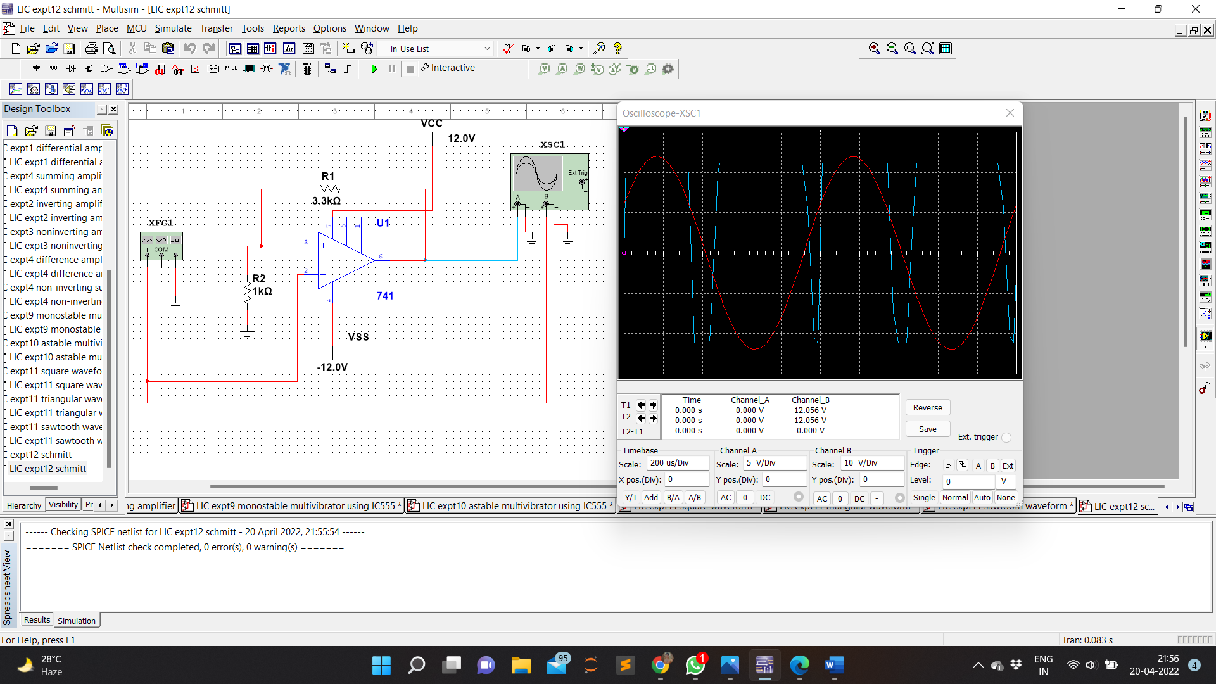

**CALCULATION:**

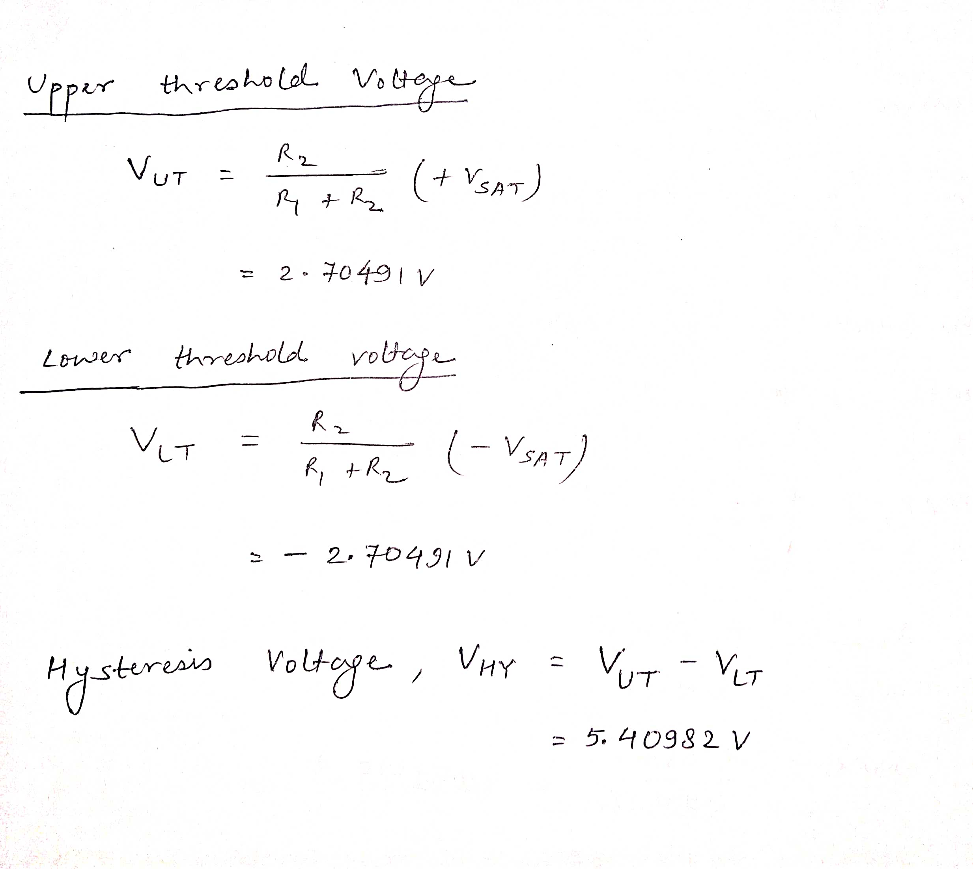

**RESULT:**

Output waveform of a Schmitt trigger circuit was observed through the design simulated and the hysteresis voltage VHY is calculated with reference to upper and lower threshold voltages VUT and VLT respectively.